# 后台校验

在Action类所在包下创建一个XML.(针对某个方法校验)

* Action类名-方法对应路径名称-validation.xml

* UserAction-user_regist-validation.xml

* 引入DTD.

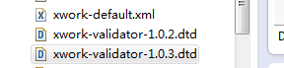

* 编写校验:

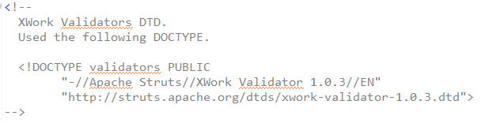 * 校验后的INPUT视图配置.

UserAction-user_regist-validation.xml

<?xml version=*"1.0"* encoding=*"UTF-8"*?>

<!DOCTYPE validators PUBLIC

"-//Apache Struts//XWork Validator 1.0.3//EN"

"http://struts.apache.org/dtds/xwork-validator-1.0.3.dtd">

<validators>

<field name=*"username"*>

<field-validator type=*"requiredstring"*>

<message>后台：用户名不能为空!</message>

</field-validator>

</field>

<field name=*"password"*>

<field-validator type=*"requiredstring"*>

<message>后台：密码不能为空!</message>

</field-validator>

<field-validator type=*"stringlength"*>

<param name=*"maxLength"*>12</param>

<param name=*"minLength"*>6</param>

<message>后台：密码必须在6-12位之间</message>

</field-validator>

</field>

<field name=*"email"*>

<field-validator type=*"email"*>

<message>后台：邮箱格式不正确!</message>

</field-validator>

</field>

</validators>

# 查看源码—更多校验

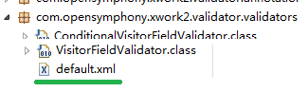

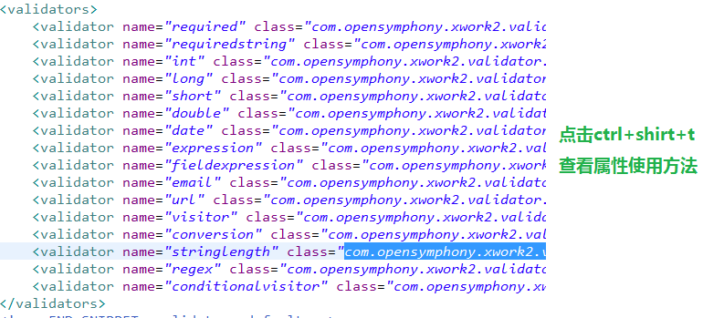

# UserAction

